The Influence Of Online Advertising On Increasing Sales Of Culinary Product Using Facebook Social Media as a Moderating Variable

Agus Kurniawan
Universitas Islam Negeri Raden Intan Lampung -aguskurniawan@radenintan.ac.id

Abstract-Social media is currently the most widely used promotional tool and place to communicate because it has a very significant impact on business development because it has advantages including the number of users and does not require costs to create an account on a social media. One of the social media that is still in demand today and has many users is Facebook. and the Facebook application itself is easily accessible to any group, does not limit age and is easy to reach. The objectives of the research are (1) The influence of online advertising in increasing sales of culinary products in Berasan Makmur Village, Mesuji Regency , (2) The ability of Facebook social media as a moderating variable in the influence of online advertising in increasing sales of culinary products in Berasan Makmur Village, Mesuji Regency , and (3) Providing an overview of the activities of culinary entrepreneurs who advertise on Facebook social media. This research uses quantitative research type. Where the researcher used primary data obtained from distributing questionnaires to 23 respondents using the Purposive Sampling Technique on students of the Sharia Business Management study program in Bandar Lampung. Namely, culinary sellers via Facebook social media in Berasan Makmur Village, Mesuji Regency .

Keywords: Online Advertising, Facebook Social Media, Product Sales

- PENDAHULUAN
The economy is important in nation building, state stability is closely related to economic stability. There is a lot of potential that can be explored from economic activities themselves, including interest in entrepreneurship on a micro-economic scale, such as setting up food stalls, daily necessities and various other forms of activities.
Islam teaches that wealth is not the goal of life, but as a means to benefit each other and meet needs. Islam places the Qur'an as a guide to the lives of its people, covering all aspects of human life. (Bahrudin, Kurniawan, and Suhendar 2022) Encouraging people to become servants of God who have a transcendental spirit (worship and sincerity) and sportsmanship (seriousness) in their work. Working in the view of the Qur'an is a form of worship in its broad sense and as a means to achieve happiness in the hereafter. Islam has removed all class differences between humans, and considers work as an obligation that must be carried out by each individual according to their capacity and ability. (Budimansyah 2016)
The public is certainly also familiar with the term new media . New media is media that runs side by side with the internet, which means that all forms of media that use the internet can be said to be new media . (Dian Permatasari and Fahrunnisa 2022) . we can see day by day the internet is stepping far into the public realm, not only in offices and universities, but has entered every home. From children to adults can already use the internet. The form of new media is usually known as social media. The increase in this economic aspect itself through new media will indirectly bring consequences for social impacts. (Kurniawan and Mustofa 2022)
Sustainability in sharia principles has values that become a kind of strength in every activity and transaction throughout the business process. An important factor in achieving sustainability, a business based on sharia principles is the existence of blessings and seeking the pleasure of Allah SWT. And this principle is the basis for business orientation to remain in the corridor of Islamic law . Several types of discussions regarding business sustainability are sustainability of capital, sustainability of human resources, sustainability of production and sustainability of marketing. (Erike Anggraeini 2022)
Marketing models in the digital industrial era change individuals or groups of people in meeting their needs. The marketing concept that has been used with a direct model has been changed to a digital marketing model, this is in line with changes in technology, with the presence of this technology the internet makes digital marketing business one of the breakthroughs in the marketing system model, the presence of digital marketing with an online system enlivens the current digital era marketing, because the online shopping system is currently one of the results of activities that have been favored by the community and almost all items searched for are done online. (Masturi, Hasanawi, and Hasanawi 2021) .
Marketing can be done through three types of media, first print media, second audio visual media and the last online media. Print media other than newspapers and magazines can be in the form of flyers, brochures, pamphlets and banners. Audio visual media or electronic media is a relatively expensive media, and is not affordable for novice entrepreneurs, because advertising a product through electronic media requires quite a large cost. Meanwhile, the cheapest and most widely used media is social media. Social media marketing is an effort to optimize social media in order to persuade consumers to a company. Valuable product or service . Social media marketing is a strategic and methodical process for building a company's influence, reputation and brand within a community of potential customers, readers and/or supporters. (Ahmad 2015) .
In addition to the development of the media, Indonesia also has many developing industries, one of which is the food industry or what we call culinary, this was explained by the Minister of Finance Sri Mulyani that the culinary industry is the largest contributor to the growth of the creative economy. Culinary in Indonesia is no longer a foreign thing because Indonesia has various kinds of typical foods from each region. This uniqueness can be an attraction in itself. The mushrooming of food businesses has made competition increasingly tight, so that every business actor must maximize their ideas and creativity to produce products that are in demand by consumers. One way to increase sales is to do marketing. (Astuti and Anggraini 2018) .

Figure 1. 1
Social Media Users in the World
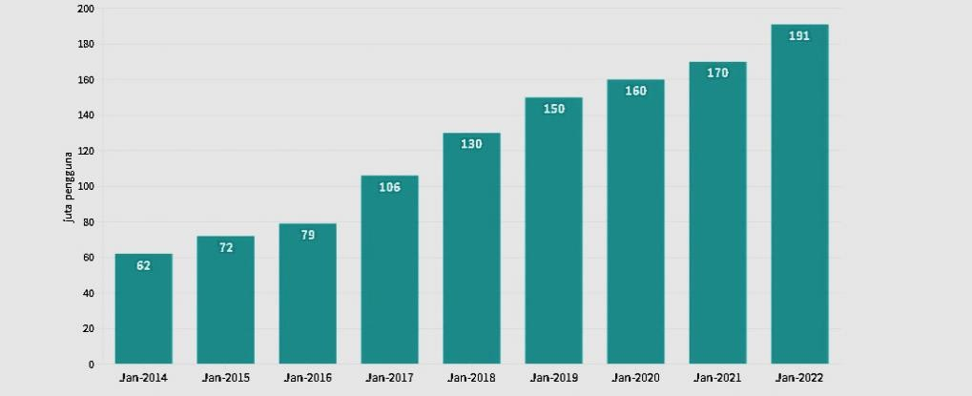
Based on the We Are Social report, the number of active social media users in Indonesia was 191 million people in January 2023. This number has increased by 12.35 % compared to the previous year which was 170 million people. Looking at the trend, the number of social media users in Indonesia continues to increase every year. However, its growth has fluctuated since 2014-2023. The highest increase in the number of social media users reached 34.2 % in 2017. However, the increase slowed to 6.3 % last year. The number only increased again in 2023. Whatsapp is the most widely used social media by Indonesian people. The percentage is recorded at 88.7 % . After that, there are Instagram and Facebook with percentages of 84.8% and 81.3% respectively . Meanwhile, the proportion of TikTok and Telegram users is 63.1 % and 62.8% respectively .
Social media is currently the most widely used promotional tool and place to communicate because it has a very significant impact on business development because it has advantages including the large number of users and does not require costs to create an account on a social media. One of the social media that is still in demand today and has many users is Facebook . and the Facebook application itself is easily accessible to anyone, does not limit age and is easy to reach. (Ayuni, Cangara, and Arianto 2019) . Facebook is the most popular social media in the world with around 2.9 billion active users throughout 2021.

Figure 1. 2

Facebook Users in the World
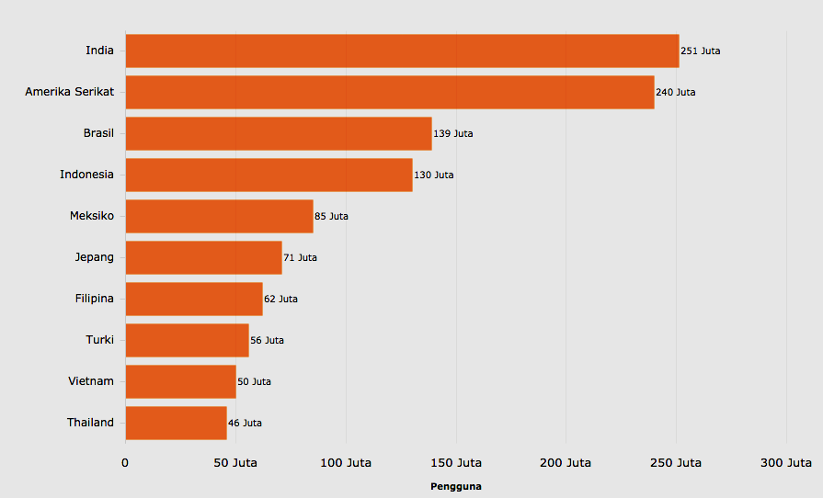
According to Statistics report as of January 2023, Indonesia has 129.85 million active Facebook users . This number places Indonesia in third place for users of the Mark Zuckerberg application in the world. India is in the top rank with a total of 329.65 million Facebook users . The United States is in second place with 179.65 million Facebook users. (katadata.co.id). Indonesia is the country with the third largest number of Facebook users in the world. Looking at the trend, the number of Facebook users in Indonesia fluctuates, tending to increase from September 2018 to July 2023. The highest increase in the number of users occurred in February 2019 to 25.8 % . Based on the meta report, the number of monthly active users (MAUs) of Facebook globally was 2.93 billion in the second quarter of 2023.
Facebook has been an application that has been around for a long time before other applications, and has become one of the largest networks in the world. Facebook has also added to its series of acquisitions, this social media has presented online advertising management and business services. Microsoft , namely Atlas Advertiser Suite (ADS). ( Ayuni, Cangara, and Arianto, Op.Cit, p.130).
Indonesia is the country with the third largest number of Facebook users in the world. Looking at the trend, the number of Facebook users in Indonesia fluctuates, tending to increase from September 2018 to July 2023. The highest increase in the number of users occurred in February 2019 to 25.8 % . Based on the meta report, the number of monthly active users (MAUs) of Facebook globally was 2.93 billion in the second quarter of 2023. On this social media, many online advertisements appear offering various kinds of offers in the form of their products. Someone who is going to sell a product by placing an advertisement on the internet or on social media must be able to clearly understand what factors can influence consumer decisions and choices, namely that the advertisement itself must consist of several procedures and general principles of the advertising code of ethics so that customers feel comfortable and satisfied.
This can be proven by a survey conducted by (PT Pricewaterhouse Coopers Indonesia Advisory together with the Institute for Development of Economic and Finance (INDEF) on June 27 to August 6, 2019. Stating that the most frequently used social media as a promotional media is Facebook, Facebook is one of the most widely used social networks by the local community, so it is not surprising that Facebook social media can be an opportunity for business beginners as well as a very potential marketing or promotional tool. Promotion on Facebook can use advertisements, videos, Market Place. Facebook is a social media that is used to promote goods in the form of advertising. In 2022, Facebook will only be second to YouTube as a social media used to promote goods in the form of advertising.

Figure 1. 3

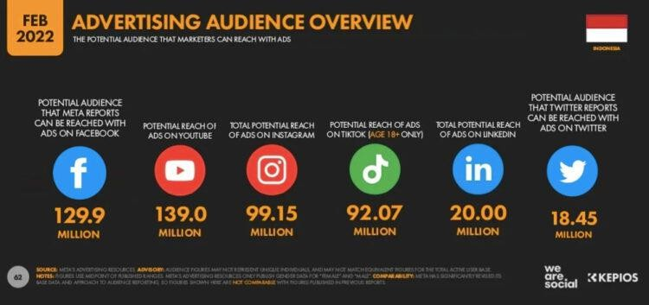
Use of social media to promote goods

media users in Indonesia based on the potential reach of advertisements (ads) on each social media. According to the Digital 2022 Global Overview Report , as of January 2022, Facebook's ad reach was 26.7% of its total user population, so Facebook ads are estimated to only reach around 776.9 million people. Youtube's ad reach potential is the largest, reaching 32.4 % , so its ads are estimated to be able to reach 830.1 million people. (katadata.co.id)
Facebook advertising as a social media must be utilized by every trader. Traders and entrepreneurs can use Facebook as a promotional medium for goods or products sold. Advertisements that are distributed on Facebook will be easily accessible by Facebook users so that product sales will increase. Traders or entrepreneurs who use Facebook as a promotional tool will not incur additional costs such as brochure printing costs. Facebook also provides services that can explain in detail about the goods lined up for sale, Facebook provides for location service, where when we press the location service then the map will easily show the location. With the ease and speed of the network that Facebook provides, it certainly helps people in getting the information . (Rafiah and Kirana 2019) .
Likewise in Berasan Makmur village, precisely in Mesuji. In this prosperous village of Berasan, it is one of the villages that is developing very rapidly, one of which is the increase in population. In this matter, of course, there are many diverse needs of the villagers , especially in their food and clothing needs. Given the increasing sophistication of smartphones that are currently on the rise and applications that are already widely used, the people of the village have used Facebook as a means to express their merchandise. Here the researcher chose the Facebook application as a marketing tool because most of those who use it are the village mothers, but it cannot be denied that teenagers and creative children have also used it. The researcher will examine whether it is true that using online advertising through Facebook social media can increase sales of their culinary products.

Grand Theory of Marketing
According to Philip Kotler, the definition of marketing is a social activity and an arrangement carried out by individuals or groups of people with the aim of achieving their goals by making products and exchanging them for a certain nominal amount to other parties.
According to Hair and Mc. Daniel defines marketing as the process of planning and implementing the conception, pricing, promotion and distribution of ideas, goods and services to create exchanges that satisfy consumers and achieve organizational goals. A good marketing concept according to a famous economist, Adam Smith, is taken from his book "The Wealth of Nation " written in 1776. Adam Smith put forward his opinion, namely " The needs of producers must consider the needs of consumers". Which means that producers do not immediately create and develop a product that is not in accordance with what is needed by a consumer.
The American Marketing Association defines marketing as an organizational function and a set of processes for delivering value to customers and managing customer relationships in ways that benefit the organization and its shareholders.
Meanwhile, marketing management is defined as an art and science in selecting target markets and obtaining, maintaining, and growing customers by creating, delivering, and communicating superior customer value. Meanwhile, the definition according to managerial, marketing is often described as the art of selling products. (Hery 2019)

Online Advertising
According to Yet Mee Lim, Ching Seng Yap, and Teck Chai Lau, a number of studies have examined the effectiveness of internet advertising in the last decade. Generally to find out how effective the online advertisement is. There are several variables that can measure the effectiveness of an online advertisement, namely recall of online advertisements, online advertisement awards , brand awareness, clicks or number of clicks, attitudes towards online advertisements and brands, and purchase considerations. From these effectiveness measures, attitudes towards online advertisements , recall of online advertisements and clicks on online advertisements are the focus of this study. These three steps are assessed by their ability to predict online purchasing decisions . (Lim, Yap, and Lau 2011)
E-Marketing according to Armstrong and Kottler is a new market that through the internet network is used as an effort to communicate a company, promotion, selling products and services through the internet network . Marketers also promote their products through social media such as Facebook. (Reza 2016) .This research uses quantitative research methods. Quantitative research is empirical research whose data is in the form of numbers. Quantitative research is a research method that produces findings that can be achieved using statistical procedures or other means of quantification (measurement) (Sandu siyoto 2015) . Quantitative method is a research methodology based on the philosophy of positivism, used to research certain populations or samples and to test predetermined hypotheses. The type of research used in this study uses a survey research type. In survey research, information is collected from respondents using questionnaires.
2. RESEARCH METHODS
This research uses quantitative research methods. Quantitative research is empirical research whose data is in the form of numbers. Quantitative research is a research method that produces findings that can be achieved using statistical procedures or other means of quantification (measurement) (Sandu siyoto 2015) . Quantitative method is a research methodology based on the philosophy of positivism, used to research certain populations or samples and to test predetermined hypotheses. The type of research used in this study uses a survey research type. In survey research, information is collected from respondents using questionnaires.
3. RESULTS AND DISCUSSION
Simple Linear Regression Test Results
- Simple Linear Regression Test Model 1
Multiple linear regression test model 1 in this study is a multiple linear regression test conducted by researchers to determine the results of the influence of online advertising variables on product sales variables. The following are the results of the multiple linear regression test model 1, namely:

Table 4. 6
Linear Regression Test Model 1
Coefficients a
Model |  |  | Unstandardized  Coefficients |  | Standardized  Coefficients | T | Sig.
 |  |  | B | Std. Error | Beta | T | Sig.
1 | (Constant) | 1.175 |  | 2.216 |  | .530 | .601
1 | Online  Advertising (X) | .484 |  | .043 | .926 | 11,250 | .000
a. Dependent Variable: Product Sales (Y)

Source: SPSS output data processed in 2024
Referring to the table above, the simple regression model of the online advertising variable on the product sales variable is as follows: 𝑌 = 1,175 + 0,484𝑋 + 𝑒
The coefficients of the simple linear regression equation above can be interpreted as the results of the simple linear regression test calculation above showing the regression coefficient on the online advertising variable has a positive sign of 0.484, meaning that every 1% increase from online advertising to product sales experiences an increase of 0.484.
- Simple Linear Regression model 2
The simple linear regression test model 2 in this study is a multiple linear regression test conducted by researchers to determine the results of online advertising variables on product sales variables with Facebook social media as a moderating variable. The following are the results of the multiple linear regression test model 2, namely:

Table 4. 7
Linear Regression Test Model 2
Coefficients a
Model |  | Unstandardized  Coefficients |  | Standardized  Coefficients | T | Sig.
 |  | B | Std.  Error | Beta | T | Sig.
1 | (Constant) | 13,721 | 1,553 |  | 8,836 | .000
 | Online  advertising* Social Media FB | .005 | .001 | .871 | 8.111 | .000
a. Dependent Variable: Product Sales (Y)

Source: SPSS output data processed in 2024
Referring to the table above, the simple regression model of the online advertising variable against the product sales variable with Facebook social media as the moderating variable is as follows:
𝑌 = 13,721 + 0,005𝑋 ∗ 𝑀 + 𝑒
The results of the simple linear regression test calculation above show that the regression coefficient on the independent variable of online advertising with Facebook social media as a moderating variable is positive at 0.005, which means that for every 1% increase in online advertising, product sales will increase by 0.005 with Facebook social media as a moderating variable.
    - Hypothesis Test Results
      - t Test
Before concluding the hypothesis is accepted or rejected, first determine with a significance of 5% based on a 2-sided test and the degree of validity ( df ) = n-1. With this test, the value of df = 22 is known and the results obtained for is 2.07387 .

Table 4. 8

Model 1 t-Test Results
Coefficientsa
Model |  | Unstandardized  Coefficients |  | Standardized  Coefficients | T | Sig.
 |  | B | Std. Error | Beta | T | Sig.
1 | (Constant) | 1.175 | 2.216 |  | .530 | .601
1 | Iklan Online (X) | .484 | .043 | .926 | 11.250 | .000
a. Dependent Variable: Penjualan Produk (Y)

Sumber : Data output SPSS diolah tahun 2024

Based on the table above, the results of the t-test can be concluded that the results of the t-test in model 1 can be seen from the calculated t value of the online advertising variable of 11.250 > 2.07387 and a significance value of 0.000 < 0.05, which means that online advertising has a significant influence on product sales.

Table 4. 9

Model 2 t-Test Results
Coefficients a
Model |  | Unstandardized  Coefficients |  | Standardized  Coefficients | T | Sig.
 |  | B | Std. Error | Beta | T | Sig.
1 | (Constant) | 13,721 | 1,553 |  | 8,836 | .000
1 | Online advertising*  Social Media FB | .005 | .001 | .871 | 8.111 | .000
a. Dependent Variable: Product Sales (Y)

Source: SPSS output data processed in 2024

Based on the table above, the results of the t-test can be concluded that the results of the t-test in model 2 can be seen from the value of the t count of the online advertising variable of 8.111> 2.07387 and a significance value of 0.000 <0.05, which means that online advertising has a significant influence on product sales with Facebook social media as a moderating variable.
      - Determination Test (R2 Test)
In this study, there are 2 models of determination coefficient test results. The results of the determination coefficient test model 1 are as follows:

Table 4. 10
Results of the Determination Coefficient Test for Model 1
Model Summary b
Model | R | R Square | Adjusted R Square | Std. Error of the Estimate
1 | .926 a | .858 | .851 | 1,578
a. Predictors: (Constant), Online Advertising (X)
b. Dependent Variable: Product Sales (Y)

Source: SPSS output data processed in 2024
From the results of the determination coefficient test in the table above, it can be seen that the determination coefficient is seen from the Adjusted R Square value of 0.858. Based on the test results, it shows the magnitude of the ability of the independent variable of online advertising to explain the dependent variable of product sales in this study, which is 85.8 % .
Then the results of the determination coefficient test for model 2 are as follows:

Table 4. 11
Results of the Determination Coefficient Test for Model 2
Model Summary b
Model | R | R Square | Adjusted R Square | Std. Error of the Estimate
1 | .871 a | .758 | .746 | 2,057
a. Predictors: (Constant), Online advertising* FB Social Media
b. Dependent Variable: Product Sales (Y)

Source: SPSS output data processed in 2024
Based on the results of the determination coefficient test in model 1, which is 0.858 or 85.8%, while the results of the determination coefficient test in model 2 are 0.758 or 75.8%. Based on this, it is known that the value of the determination coefficient of the determination coefficient of model 1 is greater than the value of the coefficient of model 2.
Thus, it can be concluded that the existence of Facebook social media as a moderating variable is less able to strengthen the relationship between online advertising variables and product sales variables.

Discussion
This discussion was conducted to determine whether Facebook social media is able to moderate and influence Online Advertising in Increasing Culinary Product Sales in Berasan Makmur Village, Mesuji Regency. The description of the results of this study is as follows:
- The influence of online advertising in increasing product sales
Based on the results of the analysis using the hypothesis test, the results of the t-test in model 1 can be seen from the value of the t count of the online advertising variable of 11.250> 2.07387 and a significance value of 0.000 <0.05, which means that online advertising has a significant influence on product sales. The results of the analysis explain that the use of online advertising can increase product sales. Advertisement is an information media that is made in such a way as to attract an audience to buy the products offered. With certain characteristics and persuasive so that consumers are willingly encouraged to do something social as desired. (Shiratina et al. 2020) Online advertising is an online marketing tool by displaying a website on search engine search results in a paid way . With online advertising, it will affect the sales of a product.
This study aims to determine the influence of social media on product sales. The results of the social analysis test show that social media has a significant influence on product sales. The resulting influence is a positive influence, meaning that the more online advertising is done, the more product sales will increase.Online advertising can also be described as the activity of placing advertisements to offer products or services through cyberspace, the purpose of which is none other than to gain profit from sales activities. The use of online advertising in promoting products to make it easier for business actors to introduce their products to consumers. The wide reach of online advertising to various regions or countries in a short time will be able to increase product sales.
According to Lina and Rismawati, online advertising has a positive influence on product sales, this is because online advertising is accessed by many consumers from various regions in a short time. Research conducted by Adhita Maharani Dewi explains the use of online media in promoting products to consumers, is able to increase sales because the scope of the promotion is so broad. (Dewi 2018) . Based on the results of this study, it states that online advertising can influence product sales, so online advertising has a role and task to promote products in socializing and conveying information about products to consumers.
- The influence of online advertising in increasing sales of culinary products moderated by Facebook social media
Based on the results of the analysis using the hypothesis test, the results of the t-test on model 2 can be seen from the value of the t count of the online advertising variable of 8.111> 2.07387 and a significance value of 0.000 <0.05, which means that online advertising has a significant influence on product sales with Facebook social media as a moderating variable. The results of the analysis explain that the use of Facebook social media as a place for online advertising promotion can increase product sales.Social media is content containing information created by people who utilize publishing technology, is highly accessible and is intended to facilitate communication, influence and interaction with others and with the general public. (Yusmanizar et al. 2020) Facebook Ads is a feature offered by Facebook to promote or advertise a Fan Page that has previously been created by a Facebook user with a different reach and can be set by the advertiser. Facebook ads are paid messages that come from businesses and include social contexts about friends, the cost of advertising on Facebook is cheaper than advertising on other social media such as Instagram or Google. The increasing number of Facebook users every year will provide benefits for business actors to advertise their products on Facebook social media. According to Nur Jannah and Maria, the use of Facebook social media can have a positive and significant influence in increasing consumer buying interest so that it has an impact on increasing product sales (Maria, 2023)
This study aims to determine the influence of social media on product sales moderated by Facebook social media. The results of the statistical analysis test show that social media has a significant influence on product sales moderated by Facebook social media. The resulting influence is a positive influence, meaning that the more online advertising is done, the more product sales will increase, which is moderated by Facebook social media.
One of the uses of information technology in libraries is by using social media for various library interests. Social media is a tool, service and communication that facilitates relationships between people and others who have the same interests or interests . (Kartini et al. 2020) . The benefit of product promotion using Facebook ads is the level of practicality when used to interact or communicate and take care of various things. The Internet functions as an interactive medium where a company can provide direct responses to questions asked by consumers. This interactive nature allows the internet to be a medium that can be used to conduct buying and selling transactions or e-commerce which can ultimately give rise to a desire to buy and end in a purchasing decision. According to Yani Dwi, the use of social media Facebook in advertising products can provide a positive and significant influence on increasing sales volume, this is due to the increase in the number of Facebook users and the low cost of advertising products on Facebook. (Restanti, 2023)

4. CONCLUSION
Based on the research results and analysis that the researcher explained in the previous chapters, the following conclusions can be drawn, advertising has a significant positive influence on the sales of culinary products in Berasan Makmur Village, Mesuji Regency. Online advertising has a significant positive influence on the sales of culinary products moderated by Facebook social media in Berasan Makmur Village, Mesuji Regencay. For Culinary Traders in Berasan Makmur Village, this is expected can increase the quality and quantity of promotional products culinary through social media advertising on Facebook. For Further Researchers For further researchers It is hoped that this research can become an internal reference developing further research, and is also expected to further develop the variables and indicators so that they can produce a clear picture even wider.

REFERENCES

Akhmad, Khabib Alia. 2015. “Utilization of Social Media for the Development of UMKM Marketing (Qualitative Descriptive Study on Distro in Surakarta City).” DutaCom Journal 9(1):45.
Amalia Yunia Rahmawati. 2020. Author No Title No Title No Title .
Astuti, Dewi Mudji, and Melaty Anggraini. 2018. “Gastrodiplomacy as a Strategy for Developing Indonesia’s Culinary Tourism Potential in Supporting the ASEAN Tourism Strategic Plan (ASTP) Program.” National Seminar and Multidisciplinary Panel Discussion of Research Results & Community Service 182.
Ayuni, Qurata, Hafied Cangara, and Arianto Arianto. 2019. “The Influence of Digital Media Use on Sales Level of Culinary Package Product Among Female Entrepreneurs.” Journal of Communication and Public Opinion Research 23(2):194.
Bahrudin, Moh, Agus Kurniawan, and Suhendar. 2022. “The Role of Zakat in
Economic Growth in Lampung Province (Study at Baznas Bandar Lampung City).” Scientific Journal of Islamic Economics 8(2):1513–21.
Budimansyah. 2016. “Work Ethic in the Qur'an.” (2):1–23.
Dewi, Adhita. 2018. “The Influence of Online Advertising Through Instagram On.” Journal of Economics, University of Kadiri 3(1):2.
Dian Permatasari, and Fahrunnisa. 2022. “Facebook as a Culinary Promotion Media in Sumbawa Regency.” KAGANGA KOMUNIKA: Journal of Communication Science 3(2):122.
Erike Anggraeini. 2022. “Analysis of Digital Marketing and Sharia Economic Literacy on the Income of Small and Medium Industry Actors in Lampung Province Through E-Commerce.” Scientific Journal of Islamic Economics 8(02):1526–31.
Hery. 2019. Marketing Management . Jakarta: PT Grasindo.
Kartini, Ineke Maili Ningrum, Juni Ervina Sari, and Khoirunnisa. 2020.
“Research on Facebook.” Journal of Non-formal Education 3(2):146–53.
Kurniawan, Agus, and Ulul Azmi Mustofa. 2022. “Implementation of Environmental Accounting in Village-Owned Enterprises to Realize Green Accounting (Case Study of Adijaya Village-Owned Enterprises, Central Lampung).” Fiduciary : Journal of Finance and Banking 5(1):87–98. doi: 10.24127/jf.v5i1.695.
Lim, Yet Mee, Ching Seng Yap, and Teck Chai Lau. 2011. "The Effectiveness of Online Advertising in Purchase Decision: Liking, Recall and Click." Australian Journal of Basic and Applied Sciences 5(9):1517–24.
Madnasir. 2022. “Analysis of the Implementation of Islamic Work Ethics, Green Economy and Welfare in the Perspective of Islamic Economics.” Journal of Islamic Economics 8(03):3476–86.
Masturi, Hasanawi, Asyrafinafilah Hasanawi, and Adib Hasanawi. 2021. “Analysis of MSME Strategy in Facing Crisis in the Covid-19 Pandemic Era.” Journal of Research Innovation 1(10):1548.
Muhammad, Yusuf. 2018. RESEARCH DATA ANALYSIS . 1st ed. Bogor: PT. IPB Press Publisher.
Munir, Muhammad Sirojul, Muhammad Husni Mubarok, Iain Kudus, and Iain Kudus. 2024. “Digital Marketing Strategy According to Islamic Perspective in Increasing Sales Volume of UD Gebyok Sekarjati Jepara.” 2(1):59–71.
Observation. 2024. Observation of Data Research at Berasan Makmur Village Hall . Nur Majid Musthofa. Berasan Makmur.
Rafiah, Kurnia Khafidhatur, and Desty Hapsari Kirana. 2019. “Analysis of Social Media Adoption as a Digital Marketing Tool for Food and Beverage SMEs in Jatinangor.” Jesya (Journal of Economics & Sharia Economics) 2(1):188– 98.
Reza, Faisal. 2016. “Lazada.Co.Id Online Sales Promotion Strategy.” Journal of Communication Studies 4(1):64–74. doi: 10.24198/jkk.vol4n1.6.

Sahir, Syafrida Hafni. 2022. This book was written by a lecturer at the University of Medan Area. Copyright is protected by law. It has been deposited to the UMA repository on January 27, 2022
Sandu Siyoto, M. Ali Shodik. 2015. BASIS OF RESEARCH METHODOLOGY . Yogyakarta: Literasi Media Publishing.
Shiratina, Aldina, Deru R. Indika, Imas Komariyah, Dewi Kania, Eka Hendriani Solihin, Keywords, Online Advertising, Online Marketing, and Consumer Interest and Purchase. 2020. Online Marketing Through Digital Advertising Implementation . Vol. 2.
Sugiono. 2013. Educational Research Methods: Quantitative, Qualitative and R&B Approaches, . Bandung: Alfa Beta.
Yusmanizar, Thahir, Alimuddin Unde, and Muhammad Yunus. 2020. “Analysis of Characteristics of Social Media Usage in.” Jurnalisa 06(November):200– 215.

